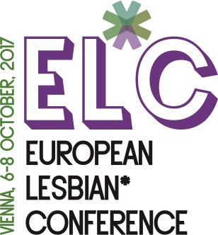

1st European Lesbian* Conference - Vienna, Austria, 6-8 October 2017

2017: Current situation of Lesbians* across Europe

DEADLINE FOR SUBMITTING APPLICATION FORM: 30th JUNE 2017
The European Lesbian* Conference offers funding for lesbians* who would otherwise be unable to participate in the conference for financial reasons. We are only able to offer this for a limited number of participants, and therefore encourage you to seek funding in advance within your organisation or through other sources (e.g. benefit events, local embassies, etc.).

1. Name:

3. Gender:

4. Please specify if you identify as an older person, a disabled person, black or belong to an ethnic minority:

5. Country of citizenship:

6. Country of residence:
7. Organisation:

8. Contact address:

9. Telephone (or mobile):

10. Email:

11. Travel expenses / Estimate of travel expenses:

Visa requirements:
If you need an invitation letter for a visa, please specify:
Full name as it appears in your passport
Nationality as it appears in your passport
Date of birth
Place of birth
Passport no.
Date of issue of your passport
Expiration date of your passport
Contact information of the Embassy you’ll be applying to for visa (including a fax number and full postal address)

Please answer the following questions:

- Please provide details of your background regarding activism in the lesbian movement, within lesbian organisations, initiative groups, etc. (200-400 words).

- Please provide details of your motivation to take part in the European Lesbian* Conference (300-400 words):

- Please outline how you hope to use the experience gained through the conference for your daily work and how your participation in the conference will be of benefit to you or your organisation/group and to the European Lesbian* Conference itself (300-400 words).

- Which costs would you want to be covered by EL*C funding?
Travel expenses
Accommodation
Meals
Please download and complete this form, then return it in MS Word format via:
- Email to: info@europeanlesbianconference.org
European Lesbian* Conference
Praterstrasse 66, 1020 Vienna
Date: | City:
Signature:

